ContentS
Technical Solution
PROJECT MANAGEMENT system
1 Introduction 3
2 System Architecture 4
2.1 Foundation 4
2.1.1 Hexagonal Architecture 4
2.2 Components 6
2.2.1 Workflow designer application and Workflow execution engine web service 6
2.3 Technology stack 8
2.3.1 Wiring 8
2.3.2 Relational data store 8
2.4 Development practices 9
2.4.1 Testing 9
2.4.2 Source code management 9

Introduction
This document describes high level system architecture and some implementation details of functional requirements for Project Management System.
The system architecture is designed to meet the functional, performance and security requirements for Project Management System. Following challenges are considered:
Scalability
The architecture is designed to provide support for different number of users and different amounts of data transfer without affecting systems functionality and reliability. Hence, the system will be able to retain all of its operations with an initially accepted level of quality and performance.
Be easily extensible
Built around loosely coupled components, the system will be easily extendible to cope with new functionalities as well as to adapt to future requirements;

System Architecture

Foundation
The proposed system architecture is founded on the principles of Hexagonal Architecture.

Hexagonal Architecture
The problem
Most projects battle a common problem in software development which is the infiltration of business logic in the UI and the infrastructure (e.g. data access layer). Some of the problems which result from this coupling include:
- The testing of the business logic using automated tests is hard and ineffective due to its coupling with UI and infrastructure.
- It becomes difficult to implement alternative presentations which would allow the application to be accessed from a different client such as a desktop or mobile client.
- It’s difficult or impossible to alter initial infrastructure choices such as replacing a relational database with a NoSQL database.
Although all projects get off to a good start, the reason why this happens to many of them is the lack of mechanism that would detect the existence of this type of coupling. Using the well-known N-Layered architecture to separate the business logic from the UI and infrastructure is not a real solution to the problem due to the existence of transitive dependencies between higher levels on lower levels (e.g. the business logic and the UI depend on the data access layer).
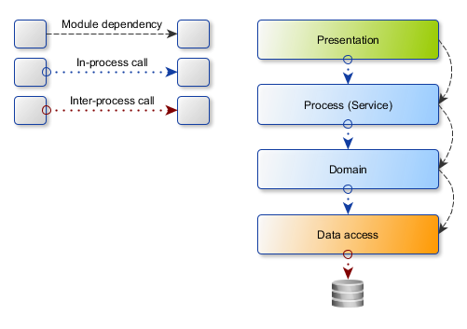
Figure 1 - N-layered architecture dependencies
The solution
The business logic is the hearth of any application and should therefore be the central piece around which everything else is organized. In other terms, the business logic should not be dependent on and should not infiltrate the UI and the infrastructure but should instead communicate with these external agents using ports which take the form of an API. Each external agent is then connected to a specific port using an adapter. The resulting architecture is the so called Hexagonal Architecture also known as Ports and Adapters.
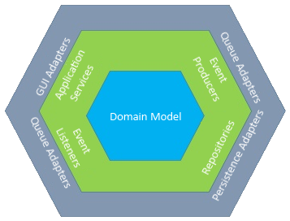
Figure 2 - Hexagonal Architecture a.k.a. Ports and Adapters
The benefit of this approach is that the domain model along with its ports, which together form the application core, are shielded from any changes to the outside. For example, switching to a NoSQL database or an in-memory database during automated testing is merely an alternative persistence adapter implementation which does not affect the application core in any way.

Components
The following diagram represents the high-level system architecture depicting its most important components.
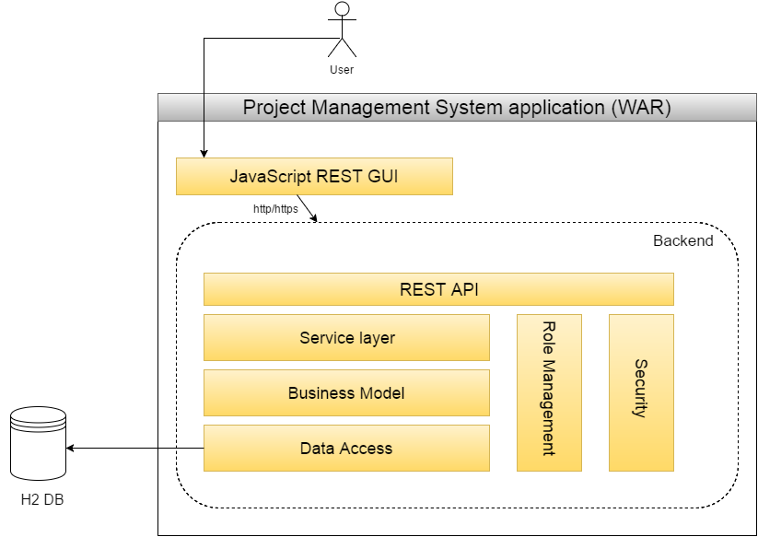
Figure 3 - High-level system architecture

project management system application
Project management system application is an independent deployable war, provides web interface for users, projects and tasks management.

Technical implementation
Web service implementation for the project management system application is REST - natural choice in the place where GUI frontend (javascript) commutates with GUI backend (java).

The grounds for the chosen approach are following.
REST
A REST based approach using JSON for data representation is considered the de facto standard nowadays when it comes to this type of system integration. A well-known advantage of this type of integration is the sheer simplicity of the approach and the fact that it’s well supported by all development platforms meaning less interoperability issues. Other benefits include transport over the HTTP protocol which is universally supported by all development platforms and is considered network-friendly in the sense that HTTP traffic is usually not blocked by company firewalls.

Development platform
The system architecture design of the Project Management system is based on a mature JAVA enterprise technology stack that assures maximum system performance and stability as well as portability across a range of platforms therefore providing a great level of flexibility.
System core
The very core of the system is based around the Spring framework which provides the Inversion of Control (IoC) container allowing Dependency Injection (DI) to be used, a very important precondition for achieving a loose-coupled architecture where components depend on abstractions rather than concrete implementations.
Data access
The Spring Data Access component from Spring’s framework shall be used as much as possible.
Where applicable, the components from the Spring Data project shall be used in order to receive benefits such as support for CRUD operations, out of the box pagination and sorting as well as writing custom queries using only interfaces thus eliminating the need for writing infrastructure code and significantly reducing the implementation time.
Security
Authentication is implemented using Software-as-a-Service (SaaS) provider’s Log-in product. Currently Facebook and GitHub are supported but adding new providers is very simple task. Spring Social component from Spring’s framework is used for this purpose. It gives rich and high level API to establish connections with SaaS. Under the hood authentication is conducted through OAuth2 protocol.
Authorization is based on the Spring Security component.
Rest API
Spring MVC helps not only to build user interface but also is well suited to be used for RESTful web service implementation.

Technology stack
The implementation of the proposed system architecture will be based on a Java technology stack:
- Wiring (IoC container): Spring Core
- Configuration: Spring Boot
- Web UI: Spring MVC, Thymeleaf, jQuery, Twitter Bootstrap, HTML5, CSS3
- Relational data store/access: H2, Liquibase (schema management), Spring Data JPA, Spring Data JDBC Extensions
- Testing - *In Plan: TestNg, Mockito, H2
- Build tool: Maven

Wiring
The Spring framework provides the component model and allows for all components to be wired together. It also provides implementation for cross-cutting concerns such as transaction management and aspect oriented programming (AOP) whenever necessary.

Relational data store
Some parts of the system, rely on a relational data store for data persistence. Using abstraction such as JPA and Hexagonal Architecture, the application code will be kept as loose coupled as possible from the concrete data store implementation.
When working with a relational data store, one very important thing to have in mind is the version management of the database schema. Not keeping track of what changes have been applied to the schema during new feature development can result in a lot of unexpected problems during the rollout of those changes. Liquibase is a relational database source control system that allows the database schema to be migrated from one version to another.

Development practices

Testing
Bugs caught early in the development process are less costly to be fixed than those caught during testing and significantly less costly than those caught in production. It is therefore very important that automated tests are present to cover the various execution paths of the application code. These tests also act as a safety net during refactoring which could potentially affect existing functionality.
Testing the different segments of an application requires different approaches. For example, testing the domain model, where the business logic resides, is best done using unit testing where all external dependencies to the system under test (if any) are substituted with test doubles such as stubs, spies or mocks. On the other hand, testing the data access layer requires that SQL queries are executed against a real database and in the context of transactions so the database needs to be populated with test data prior to the execution of each test.
The combination of technologies and tools which will be used to achieve includes the likes of TestNg, DbUnit and Liquibase among others.
Finally, it’s important to keep track of what code has been unit tested.

Source code management
All project artifacts which will be created during the development phase, including the source code and the documentation, will be stored in a GIT source code management system.

